EX 02 | CURRENCY CONVERTER
11-07-19 | CURRENCY CONVERTER

AIM:

To develop a java console application to implement currency,distance and time conversion using
packages.

REQUIREMENT:

Java application to implement currency converter ( Dollar to INR, Euro to INR, Yen to INR and
vice versa), distance converter(meter to km, miles to km and vice versa) using packages.
Create a package converterlibrary
->Create a class CurrencyConverter and define methods for dollarsToINR, euroToINR,
yenToINR and vice-versa.
->Create a class DistanceConverter and define methods for meterToKM, milesToKM and
vice-versa.
->Create a class TimeConverter and define methods houyrsToMinutes, hoursToSeconds and
vice-versa.
Create a package converteapp
->Create a class Calculation1 use the conversion functions and display the results.

ALGORITHMS:

Step 1: Create class CurrencyConverter with required methods in package converterlibrary.
Step 2: Create class DisctanceConverter with required methods in package converterlibrary.
Step 3: Create class TimeConverer with required methods in package converterlibrary.
Step 4: Create class Calculation1 with static main function in package converterapp.
Step 5: Import converterlibrary.
Step 6: Use switch case to perform the required task/
Step 7: Get data, compute and display.

CLASS DIAGRAM:
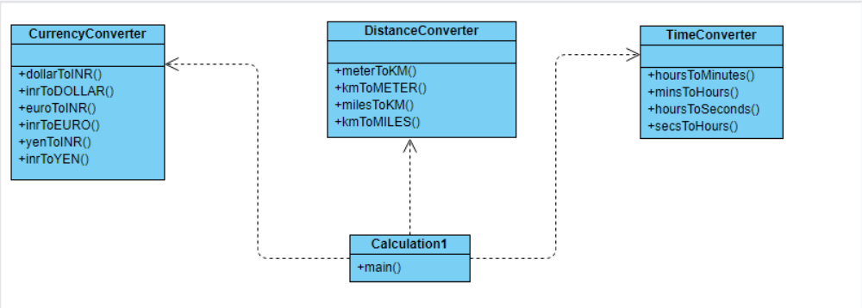

PROGRAM:
---------------------------------------ConverterLibrary-------------------------------------------
…………………………………………..CurrencyConverter……………………………………………….
/*created by: Abhijith.S
* Gmail:abhijithabhi524@gmail.com
*/
package converterlibrary;
public class CurrencyConveter
{
public static double dollorToinr(double dollor)
{
double inr;
inr=dollor*65.3;
return inr;
}
public static double inrTodollor(double inr)
{
double dollor;
dollor=inr/65.3;
return dollor;
}
public static double euroToinr(double euro)
{
double inr;
inr=euro*77.21;
return inr;
}
public static double inrToeuro(double inr)
{
double euro;
euro=inr/77.21;
return euro;
}
public static double yenToinr(double yen)
{
double inr;
inr=yen*0.63;
return inr;
}
public static double inrToyen(double inr)
{
double yen;
yen=inr/0.63;
return yen;
}

}
…………………………………DistanceConverter……………………………….

/*created by: Abhijith.S
* Gmail:abhijithabhi524@gmail.com
*/
package converterlibrary;
public class DistanceConverter {
public static double mtrTokm(double mtr)
{
double km;
km=mtr/1000;
return km;
}
public static double kmTomtr(double km)
{
double mtr;
mtr=km*1000;
return mtr;
}
public static double mileTokm(double mile)
{
double km;
km=mile/0.62137;
return km;
}
public static double kmTomile(double km)
{
double mile;
mile=km*0.62137;
return mile;
}
}
…………………………………TimeConverter…………………………………..

/*created by: Abhijith.S
* Gmail:abhijithabhi524@gmail.com
*/
package converterlibrary;
public class TimeConverter {
public static double hrsTomin(double hrs)
{
double min;
min=hrs*60;
return min;
}
public static double minTohrs(double min)
{
double hrs;
hrs=min/60;
return hrs;
}
public static double hrsTosec(double hrs)
{
double sec;
sec=hrs*3600;
return sec;
}
public static double secTohrs(double sec)
{
double hrs;
hrs=sec/3600;
return hrs;
}
}
-----------------------------------------ConverterApp-----------------------------------------
……………………………………Calculations…………………………………….
/*created by: Abhijith.S
* Gmail:abhijithabhi524@gmail.com
*/
package converterapps;
import java.util.Scanner;
import converterlibrary.CurrencyConveter;
import converterlibrary.DistanceConverter;
import converterlibrary.TimeConverter;
public class Calculation1 {

public static void main(String[] args) {
double a1,a2;
int option;
Scanner sc=new Scanner(System.in);
while(true)
{
System.out.println("1. Doller to INR conversion");
System.out.println("2. INR to Doller conversion");
System.out.println("3. Euro to INR conversion");
System.out.println("4. INR to Euro conversion");
System.out.println("5. Yen to INR conversion");
System.out.println("6. INR to Yen conversion");
System.out.println("7. Meter to Kilometer conversion");
System.out.println("8. Kilometer to Meter conversion");
System.out.println("9. Miles to Kilometer conversion");
System.out.println("10. Kilometer to Mile conversion");
System.out.println("11. Hours to Minute conversion");
System.out.println("12. Minute to Hours conversion");
System.out.println("13. Hour to Second conversion");
System.out.println("14. Second to Hour conversion");
System.out.println("15. Exit");
System.out.print("Enter your choice:");

option=sc.nextInt();
switch(option)
{
case 1:
System.out.print("Enter the Dollers:");
a1=sc.nextDouble();
a2=CurrencyConveter.dollorToinr(a1);
System.out.printf("%.2f INR is equal to %.2f Doller.\n", a1,a2);
break;
case 2:
System.out.print("Enter the INR:");
a1=sc.nextDouble();
a2=CurrencyConveter.inrTodollor(a1);
System.out.printf("%.2f Dollor is equal to %.2f INR.\n", a1,a2);
break;
case 3:
System.out.print("Enter the EURO:");
a1=sc.nextDouble();
a2=CurrencyConveter.euroToinr(a1);
System.out.printf("%.2f INR is equal to %.2f INR.\n", a1,a2);
break;
case 4:
System.out.print("Enter the INR:");
a1=sc.nextDouble();
a2=CurrencyConveter.inrToeuro(a1);
System.out.printf("%.2f EURO is equal to %.2f INR.\n", a1,a2);
break;
case 5:
System.out.print("Enter the YEN:");
a1=sc.nextDouble();
a2=CurrencyConveter.yenToinr(a1);
System.out.printf("%.2f YEN is equal to %.2f INR.\n", a1,a2);
break;
case 6:
System.out.print("Enter the INR:");
a1=sc.nextDouble();
a2=CurrencyConveter.inrToyen(a1);
System.out.printf("%.2f INR is equal to %.2f YEN.\n", a1,a2);
break;
case 7:
System.out.print("Enter the Meter:");
a1=sc.nextDouble();
a2=DistanceConverter.mtrTokm(a1);
System.out.printf("%.2f Meter is equal to %.2f Kilometer.\n", a1,a2);
break;
case 8:
System.out.print("Enter the Kilometer:");
a1=sc.nextDouble();
a2=DistanceConverter.kmTomtr(a1);
System.out.printf("%.2f Kilometer is equal to %.2f8 Meter.\n", a1,a2);
break;
case 9:
System.out.print("Enter the Miles:");
a1=sc.nextDouble();
a2=DistanceConverter.mileTokm(a1);
System.out.printf("%.2f Mile is equal to %.2f Kilometer.\n", a1,a2);
break;
case 10:
System.out.print("Enter the Kilometer:");
a1=sc.nextDouble();
a2=DistanceConverter.kmTomile(a1);
System.out.printf("%.2f Kilometer is equal to %.2f Mile.\n", a1,a2);
break;
case 11:
System.out.print("Enter the Hours:");
a1=sc.nextDouble();
a2=TimeConverter.hrsTomin(a1);
System.out.printf("%.2f Hours is equal to %.2f Minute.\n", a1,a2);
break;
case 12:
System.out.print("Enter the Minute:");
a1=sc.nextDouble();
a2=TimeConverter.minTohrs(a1);
System.out.printf("%.2f Minute is equal to %.2f Hours.\n", a1,a2);
break;
case 13:
System.out.print("Enter the Hours:");
a1=sc.nextDouble();
a2=TimeConverter.hrsTosec(a1);
System.out.printf("%.2f Hours is equal to %.2f Seconds.\n", a1,a2);
break;
case 14:
System.out.print("Enter the Seconds:");
a1=sc.nextDouble();
a2=TimeConverter.secTohrs(a1);
System.out.printf("%.2f Seconds is equal to %.2f Hours.\n", a1,a2);
break;
case 15:
System.out.println("Thankyou for using converter application !!!");
break;
default:
System.out.print("Please enter a valid number !!!");
}
if(option==15)
{
break;
}}}}
OUTPUT:
1. Doller to INR conversion
2. INR to Doller conversion
3. Euro to INR conversion
4. INR to Euro conversion
5. Yen to INR conversion
6. INR to Yen conversion
7. Meter to Kilometer conversion
8. Kilometer to Meter conversion
9. Miles to Kilometer conversion
10. Kilometer to Mile conversion
11. Hours to Minute conversion
12. Minute to Hours conversion
13. Hour to Second conversion
14. Second to Hour conversion
15. Exit
Enter your choice:11
Enter the Hours:12
12.00 Hours is equal to 720.00 Minute.
1. Doller to INR conversion
2. INR to Doller conversion
3. Euro to INR conversion
4. INR to Euro conversion
5. Yen to INR conversion
6. INR to Yen conversion
7. Meter to Kilometer conversion
8. Kilometer to Meter conversion
9. Miles to Kilometer conversion
10. Kilometer to Mile conversion
11. Hours to Minute conversion
12. Minute to Hours conversion
13. Hour to Second conversion
14. Second to Hour conversion
15. Exit
Enter your choice:15
Thankyou for using converter application !!!

RESULT:
Thus a java console application has been created to implement currency, time, and distance
conversion.

